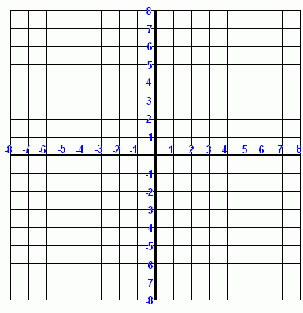Rotate the figure below 270 degrees clockwise around the origin. label the new image.
NEED HELP PLEASE HELP

