1 Use function notation to write the equation of the line.

A.
B.
C.
D.

2 Use function notation to write the equation of the line.

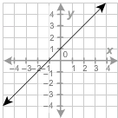

A.
B.
C.
D.
3 Use function notation to write the equation of the line.
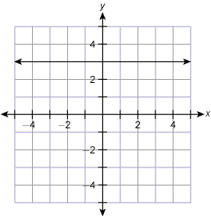

 | A. | f (x) = 3x
 | B. | f (x) = –3
 | C. | f (x) =0.3x
 | D. | f (x) = 3
4 Use function notation to write the equation of the line.
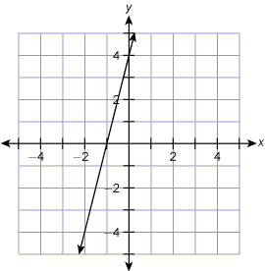

 | A. | f (x) = 4x + 4
 | B. | f (x) = –4x + 4
 | C. | f (x) = ¼x + 4
 | D. | f (x) = 4x – 1
5 Use function notation to write the equation of the line.

A.
B.
C.
D.

PART TWO:

1 Evaluate the function f(x) = 2x + 2, when x = –1.

 | A. | 4
 | B. | –4
 | C. | 3
 | D. | 0
2 Evaluate the function , when

A.
B.
C.
D.
3 Evaluate the function H(x) = 18 – x, when x = –6.

 | A. | 108
 | B. | 12
 | C. | –24
 | D. | 24
4 Find k(8) for the function k(n) = 0.007n.

 | A. | 0.0078
 | B. | 0.056
 | C. | 0.56
 | D. | 8.007
5 Find w(6) for the function w(x) = 4x + 5.

 | A. | 15
 | B. | 29
 | C. | 44
 | D. | 51

