Translate the graph according to the rule (x, y) → (x – 2, y).

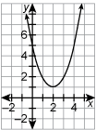

 | A. | 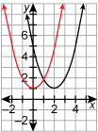
 | B. | 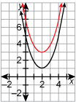
 | C. | 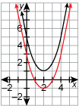
 | D. | 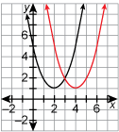
Translate the graph according to the rule (x, y) → (x– 4, y ).

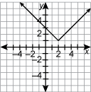

 |  | A. | 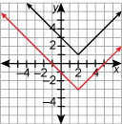
 |  | B. | 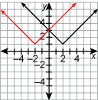
 |  | C. | 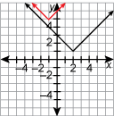
 |  | D. | 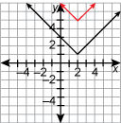
Write a coordinate rule for the translation of f(x) to g(x).

 | A. | (x, y) → (x + 3, y)
 | B. | (x, y) → (x, y + 3)
 | C. | (x, y) → (x – 3, y)
 | D. | (x, y) → (x, y – 3)

f(x) is shown in black and g(x) is shown in red.
Which is a coordinate rule for the translation of f(x) to g(x)?

 | A. | (x, y) → (x – 4, y)
 | B. | (x, y) → (x + 4, y)
 | C. | (x, y) → (x, y – 4)
 | D. | (x, y) → (x, y + 4)

